A000-Eur**-**Czech Republic-Pavlov Site 5-6-Late Paleolithic-Mammoth-Ceramic-22,000 BP

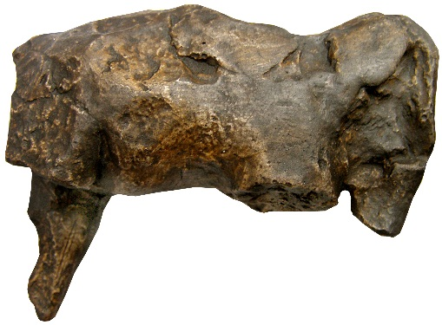 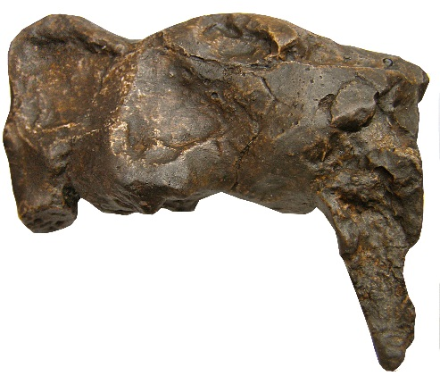

Figs. 1-2. Czech Republic-Pavlov Site 5-6-Late Paleolithic-Mammoth-Ceramic-22,000 BP

**Formal Label:** Czech Republic-Pavlov Site 5-6-Late Paleolithic-Mammoth-Ceramic-22,000 BP

**Display Description:**

**This is ceramic figurine of a mammoth which was made from clay from the banks of the** Dyje River in Moravia **as glaciers were advancing ca 22,000 BP during the LGM. Its lack of a hole for suspension as an amulet and its imperfect state of preservation suggests that it suffered from either being fragmented in the firing process and/or from having been handled roughly. If it were the first hypothesis, which is more likely, then the explosion created by too much water in the grog would have produced an impressive explosion of the clay destroying the two front limbs and the right hind limb of the mammoth. This event may have been used to invoke sympathetic magic in the hunt for mammoths as they followed the advancing glaciers at 22,000 BP.**

**Accession Number:**

**LC Classification:** DAW1023.I58

**Date or Time Horizon:** Late Paleolithic-22,000 BP

**Geographical Area:** Pavlov site 5-6, Czech Republic.

**Map:**



Fig. 3. Pavlov sites 1-9 along the Dyje River in Moravia. After Jelinek 1990. The locus of Sites 5-6 is the find spot for this figurine.

GPS:



Fig. 4. Artist’s interpretation of the village of Pavlov sites 5-6 in winter ca. 22,000 BP, painted by Giovanni Caselli. From http://www.donsmaps.com/images13/dolnivestonicelifeinwinter.jpg

**Cultural Affiliation:** Upper Paleolithic-22,000 BP-Pavlov Culture

**Medium:** original, ceramic.

**Dimensions:   
Weight:**

**Provenance: original, Archaeological Museum, Brno, Czech Republic.**

**Condition**: museum replica in resin.

**Discussion:**

Inhabitants of Pavlov VI site (Svoboda 2009) an Upper Paleolithic settlement and a satellite of Pavlov I, 200 m asl on the Dyje River in modelled baked clay figurines instead of using mammoth ivory. This ceramic figurine is a product of these Pavlov sites in the area.

**References:**

Jelinek, Jan. 1990. *Art in the Mirror of Ages: The Beginnings of Artistic Activities*. Brno: Moravian Museum.

Svoboda, Jirí, Miroslav Králík, Vera Culíková, Sárka Hladilová, Martin Novák, Miriam Nývltová Fisáková, Daniel Nývlt & Michaela Zelinková. 2009. Pavlov VI: an Upper Palaeolithic living unit, *Antiquity* 83 282-95.

Svoboda J. 2001. “Gravettian mammoth bone deposits in Moravia,” *The World of Elephants - International Congress.* Rome:International Congress. http://en.sovraintendenzaroma.it/content/download/4819/62548/file/359_362.pdf